Notes from Sarang : Dec 17, 2014

First of all, the **backend**. The basic public database has been created. I used [Parse.com](http://parse.com/" \t "_blank)'s free database service. There are 4 basic classes, or ParseObjects:

* "DayTime" - an object that stores a day of the week, and start & end times,
* "Place" - an object which stores the name of the place and a collection of DayTime objects that correspond to it, and
* "Schedule" - an object which stores a collection of Place objects
* "User" - the basic user profile for doctors, containing profile details and a single Schedule object (reference)

Second, the **frontend**. I created an Android app (a) which allows a doctor to create a profile (b). Once "Create Profile" is clicked, the user is saved on the database with an empty schedule. The user then has the ability to edit schedule from the home screen (c) and edit the details for each place (d)

. This schedule is then saved to the database, and linked to the user currently logged in.

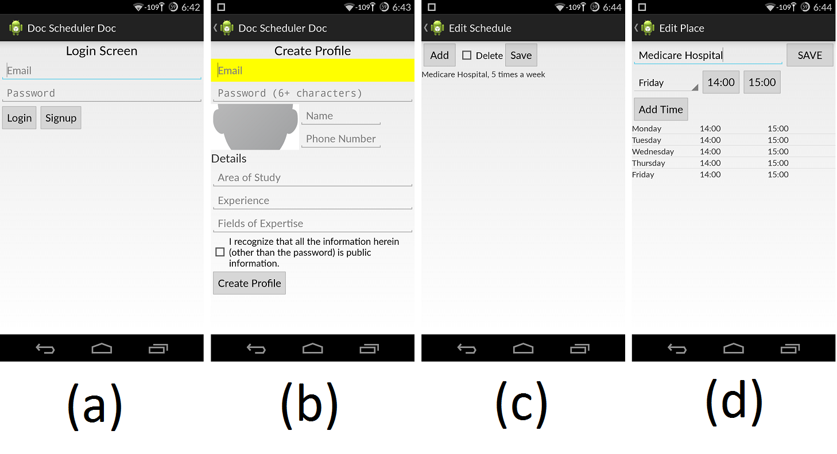

The further steps include:

* temporary local storage, so that there is no need to call the database each time the doctor wants to simply view his/her current schedule.
* a more visual layout for the schedule
* a "PatApp" for the patient to view the doctors who have registered on the public database

If you have any questions or thoughts, let me know!

Comments from Kiran (December 23, 2014)

I am commenting from the User’s perspective, as I would understand that better. I am describing the features/ workflow that should ideally happen and my understanding of whether the features/ workflows are addressed currently in the app. There are two ways of looking at the gaps if any (i) Once the gaps are confirmed, we will evaluate the criticality of the feature where the gap exists. You can describe if what is being mentioned can be currently achieved in the app and in what way. We can then evaluate if we can live with that for the prototype (ii) Fix the gaps if the issue is found to be critical even for the prototype.

**Doctor’s app**

|  |  |  |  |  |  |  |
| --- | --- | --- | --- | --- | --- | --- |
| Sr. No | Feature and the order (workflow) | Whether it is handled currently | Ideal workflow/ Info input | Is there a gap? | Comment | Sarang's Comment |
| 1 | Signup/ Register: Create Login ID, Pwd | Yes (Signup) | Create ID, Pwd, Verify Pwd, Email ID, Hint Q in case Pwd is forgotten, Captcha |  | For now, even if there is a way to send the new Pwd to email ID in case Pwd is forgotten, it should be ok. (We can even do it manually during the demo) We can live without captcha for demo |  |
| 2 | Change Pwd | ? | Click on change Pwd afer logging in, input old and new pwd |  | Not critical for demo |  |
| 3 | Create profile | Yes (Create Profile) | Create/ Edit. Identifier, Category, Specialization, Address, Contact in absence |  | Edit needed for demo to the extent that the doctor should be able to correct mistakes if any after saving data |  |
| 4 | Add places where you work | In Edit Place? | The doctor should be able to add a few places with short or detailed address e.g. Clinic, Hospital 1, Hospital 2. Later we may think of adding hospitals to database so that doctors can just pick up after searching for hospital | I guess you have covered this. In the Edit place screen, I presume the doctor can add a few places. |  |  |
| 5 | Standard Schedule – Add standard schedule, modify standard schedule | Yes (Edit Schedule) | Since this is a core of the app and as the schedules can be complex, it should be as user friendly as possible.  To start with: | The weekly schedule for those places can be added. This schedule is reasonably stable but the doctor should be able to edit if needed (e.g. if she starts going to clinic at a different time or leaves a particular hospital). Also, if there is a very specific instruction such as “by appointment only” for a specific place like clinic, that should be displayed. We could also display “Contact in my absence” | I see “Add”, “Delete”, “Save” in the Edit schedule screen. Is there a “Modify/Edit” too?  Not all features are necessary for demo. Let me know if Edit feature is there. I will think about whether we can live with that limitation for demo. |  |
| 6 | Updates – These are updates that the doctor gives from time to time about his schedule. These updates do not end up modifying his standard schedule but are just tied to certain specific dates. E.g. On 24th Dec, I am on leave. Or on 26th morning, I may say that I am going to be late to my clinic by an hour | ? | Pick “Give Updates” and add some updates against a specific date or range of dates | At a later date, we will need to make it very user friendly to make these updates efficient (Such as picking standard updates –like “On leave” or “late by”. For now, it will be sufficient even if the doctor has to type |  |  |